

Engineering Mathematics 1

**School of Engineering &Technology**

***Applied Sciences Department***

Name: BUSHRA FATIMA

RollNo.: 24CSU265

Branch: SOET

Section: F

Faculty Coordinator: DR. SEEMA THAKRAN

## THE NORTHCAPUNIVERSITY

### Gurugram, Haryana

**LIST OF CONTENTS**

|  |  |  |
| --- | --- | --- |
| **S.No.** | **Content** | **Page No.** |
| **1.** | **MATLAB: An introduction** |  |
| **2.** | **Details of the Experiments** |  |
| 1 | How to enter a matrix, Algebra of matrices: addition, subtraction and different ways of matrix multiplication, determinant, inverse, row and column operations, Echelon form, rank of a matrix. |  |
| 2 | Solution of system of linear equations: Gauss Jordon and Gauss elimination method, How to find out eigenvalues and eigenvectors of a matrix. |  |
| 3 | Encryption and decryption of images using matrices. |  |
| 4 | For the function of two variables  (a) Find the first and second order partial derivatives of two variables and plot the graphs.  (b) Find the optimum value under a given constraint. |  |
| 5 | **(a)** To implement a simple sentiment model where change in sentiment over time is proportional to the difference between the current sentiment and a baseline sentiment level.  **(b)** To implement a simple cyber security model where the growth of a cyber security threat *T* over time *t* is proportional to the current threat level. |  |
| 6 | How to perform curve plotting for Cartesian, parametric and polar curves such as cardioids, Lemniscates and surfaces. |  |
| 7 | How to perform curve plotting for Cartesian, parametric and polar curves such as cardioids, Lemniscates and surfaces. |  |
| 8 | To calculate and visualize gradients, divergences, and curls of vector fields in 2D and 3D. |  |
| 9 | To find unit tangent and unit normal of parametric curves and directional derivatives at a point. |  |
| 10. | To perform surface and volume integration and verify Green’s theorem and Stokes’ theorem. |  |
| **3.** | **Notes/Comments** |  |

# Experiment No.- 1

Date of Performance Grade Faculty’s Signature Date

**AIM:-** To enter a matrix, Algebra of matrices: addition, subtraction and different ways of matrix multiplication, determinant, inverse, Echelon form, rank of a matrix.

A=[4 8 2; 3 7 1; 9 3 5]

B=[54 8; 2 1 7; 3 5 4]

**ADDITION:**

SUM=A+B

SUM =

9 12 10

5 8 8

12 8 9

**SUBTRACTION:**

DIFF=A-B

DIFF =

-1 4 -6

1 6 -6

6 -2 1

**MULTIPLICATION:**

M=A*B

M =

42 34 96

32 24 77

66 64 113

X=B*A

X =

104 92 54

74 44 40

63 71 31

Y=2*A

Y =

8 16 4

6 14 2

18 6 10

**DETERMINANT:**

D=det(A)

D =

-28.0000

**INVERSE:**

I=inv(A)

I =

-1.1429 1.2143 0.2143

0.2143 -0.0714 -0.0714

1.9286 -2.1429 -0.1429

**ECHELON FORM:**

R=rref(B)

R =

1 0 0

0 1 0

0 0 1

**RANK:**

R=rank(B)

R =

3

**Experiment No.- 2**

**Date of Performance Grade Faculty’s Signature Date**

**AIM:-** To find the Solution of system of linear equations: Gauss Jordon and Gauss elimination method, How to find out eigenvalues and eigenvectors of a matrix.

**EIGEN VALUES:-**

E=eig(A)

E =

12.8812

-0.5866

3.7054

**EIGEN VECTORS:-**

[C D]=eig(A)

C =

-0.5265 -0.5501 -0.0594

-0.3964 0.1084 -0.2401

-0.7521 0.8280 0.9689

//DIAGONAL OF EIGEN VALUES

D =

12.8812 0 0

0 -0.5866 0

0 0 3.7054

**Experiment No.- 3**

**Date of Performance Grade Faculty’s Signature Date**

**AIM:-** Encryption and decryption of images using matrices

r=[1 1;0 1]

for i=1:7

r=[r r;zeros(2^(i)) r];

end

img=imread('256pixels.jpg');

img=(rgb2gray(img));

img=double(img);

encry= img*r

decry=encry*inv(r)

figure(1);imshow(img,[])

figure(2);imshow(encry,[]);

figure(3);imshow(decry,[]);

**Experiment No.- 4**

**Date of Performance Grade Faculty’s Signature Date**

**AIM:-** To Find the first and second order partial derivatives of two variables for the function of two variables

syms x y

>> diff((x*sin(x)*cos(y)),x,1)

ans =

cos(y)*sin(x) + x*cos(x)*cos(y)

>> diff((x*sin(x)*cos(y)),y,1)

ans =

-x*sin(x)*sin(y)

>> diff((x*sin(x)*cos(y)),x,2)

ans =

2*cos(x)*cos(y) - x*cos(y)*sin(x)

>> diff((x*sin(x)*cos(y)),y,2)

ans =

-x*cos(y)*sin(x)

**Experiment No.- 5**

**Date of Performance Grade Faculty’s Signature Date**

**Experiment No.- 6**

**Date of Performance Grade Faculty’s Signature Date**

**AIM:-** How to perform curve plotting for polar curves such as cardioids, Lemniscates and surfaces.

**Experiment No.- 7**

**Date of Performance Grade Faculty’s Signature Date**

**AIM:-** How to perform curve plotting for Cartesian, parametric curves.

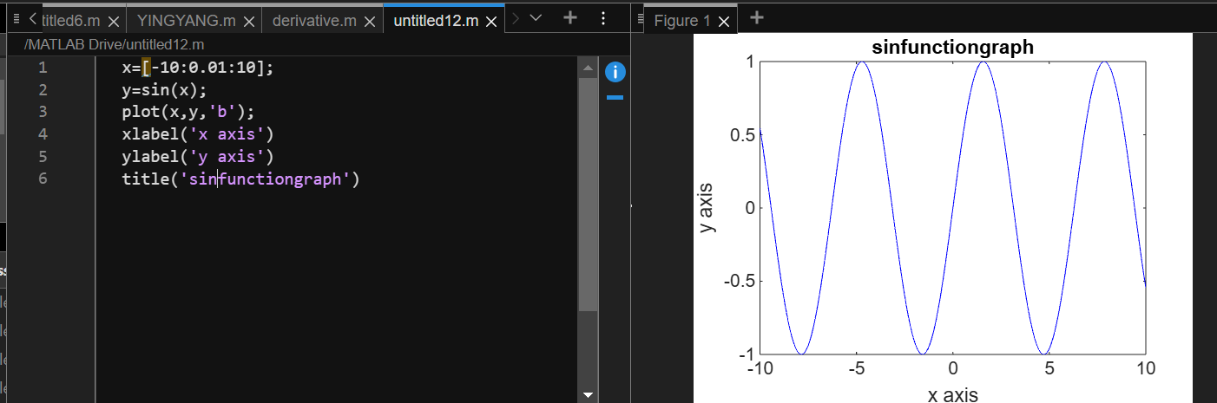

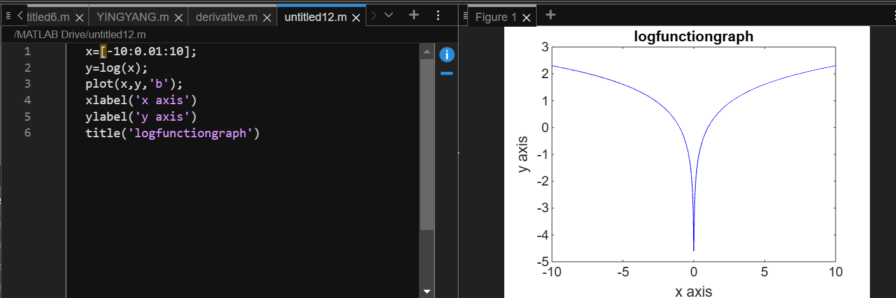

**Experiment No.- 8**

**Date of Performance Grade Faculty’s Signature Date**

**Experiment No.- 9**

**Date of Performance Grade Faculty’s Signature Date**

**Experiment No.- 10**

**Date of Performance Grade Faculty’s Signature Date**